Valencia, 9-12 April 2013

TOOLS Minutes of the 3rd Project Meeting

- SDE College (Syddansk Erhvervsskole Odense-Vejle)
- University of Southern Denmark
- Universidad Politécnica de Valencia
- Marijampolės profesinio rengimo centras
- European Association Computer-Assisted Language Learning EUROCALL
- Sabhal Mòr Ostaig College
- University of Ulster
- Universidade de Évora

Participants:
Kent Andersen | SDE, DK and Eurocall
Cecilia Leboeuf | SDE, DK
Caoimhín Ó Dónaill | Ulster, Northern Ireland
Neil Comer | Ulster, Northern Ireland
Maria João Marçalo | Évora, PT
Ana Alexandra Silva | Évora, PT
Caoimhín O Donnaile | SMO, Scotland
Rasa Zygmantaite | MPRC, LT
Simona Dapkunaite | MPRC, LT
Helle Lykke Nielsen | SDU, DK
Omar Dhahir | SDU, DK
Ana Gimeno Sanz | UPV, ES

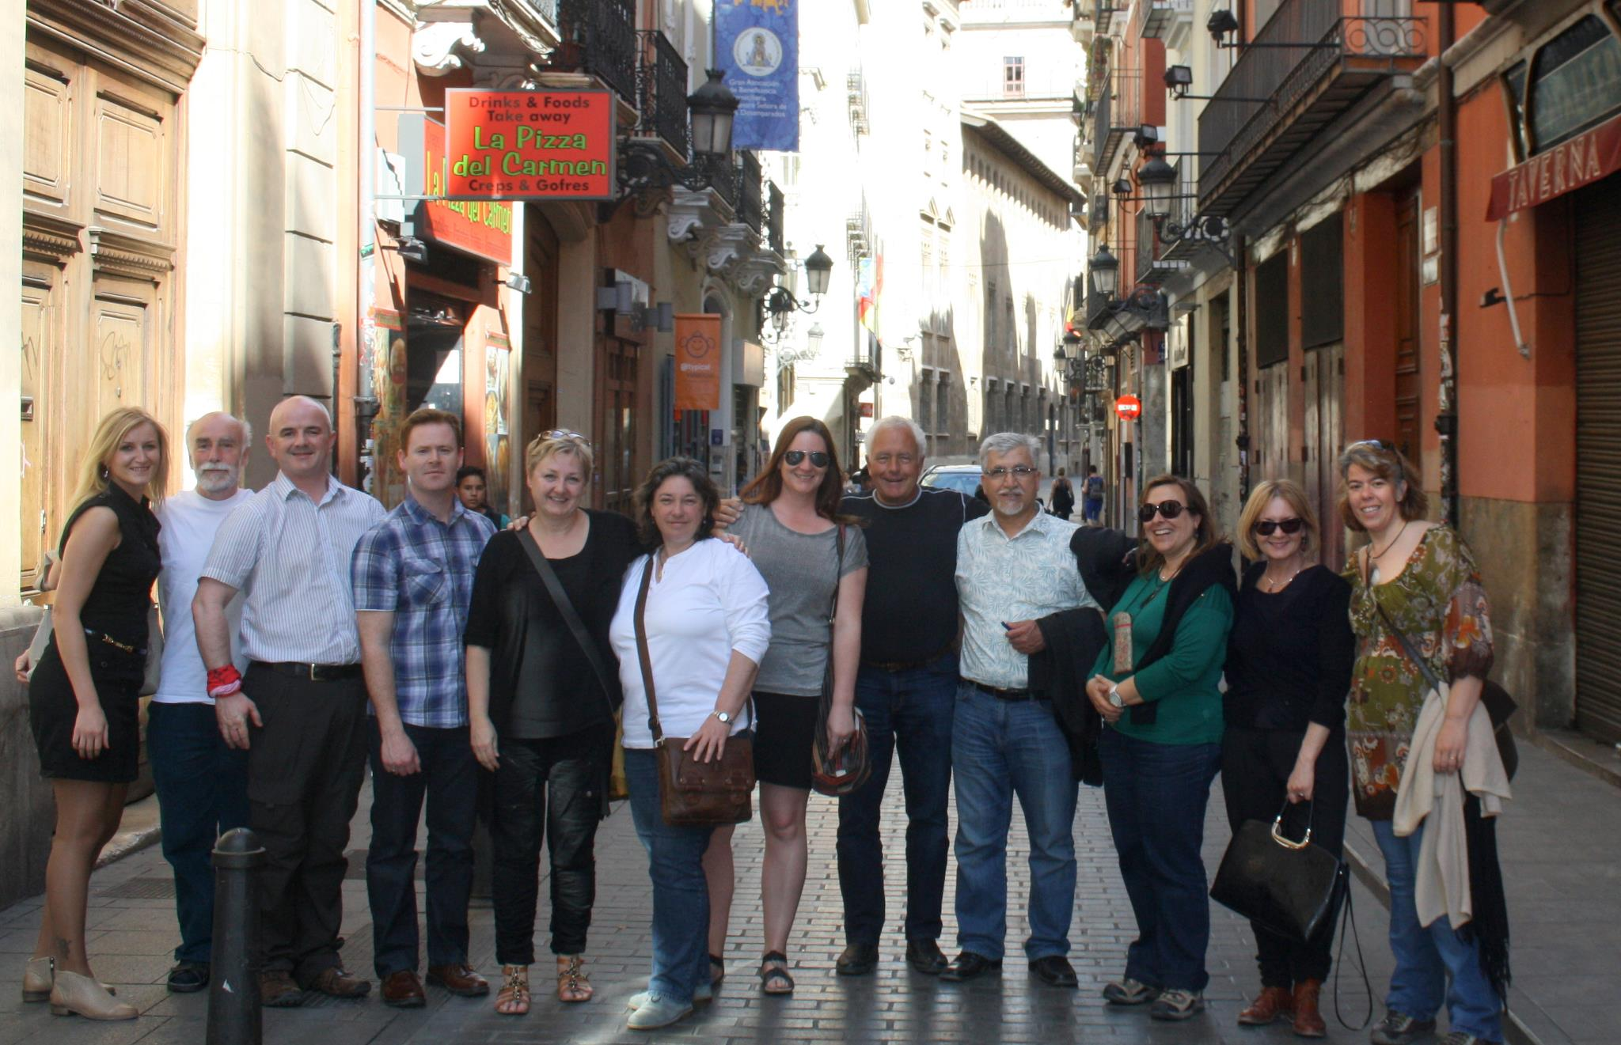

Tuesday April 9th
The first day saw the arrival of all the teams and was dedicated teambuilding and social events.

Wednesday April 10th

Activities since the Eurocall workshop / project status
- Ana G-S course book development work in progress with Ulster team.
- SDE, testing and presenting CLILSTORE with courses in Malta and Rome with good and positive feedback. Feedback on dictionaries has been sent to SMO. Article submitted and accepted in the Danish language teacher magazine “Sprogforum”. Editing and writing articles for the project newsletters. Lone Olstrup has been working on the layout and design of CLILSTORE. Main activity is to compile interim report, sent to all participants.
Looking at design and testing of CLILSTORE
- SMO, move to new hardware, new address and new updated computer, faster machine and discs for backup and operating system. Change of address, so it is now multidict.net. Lone’s visit has been positive, and a lot of work being done on the technical part of CLILSTORE, where student page and author page, simplified. Advertising for the site with links. Teacher courses have been held, where the use of CLILSTORE has been applied. Cleaning out units and users, who have not got e-mails or names. Suggestions on rating users.
- Ulster: test the system, and experimenting with the creation of units, creating surveys, and finding ways of presenting materials to students in class. Positive reactions from students. Course in Dublin, St. Patricks College, course for teachers, with good results, hopefully a new workshop will come up. January, conducted workshop at the LLAS Annual eLearning Conference at the University of Southampton giving an introduction to the system and using the CLILSTORE. Some problems were discovered, resulting in some bug fixes. Prepared educational showcase on CLILSTORE for WorldCALL, with follow-up, and posters presenting CLILSTORE. Involved in design discussions, and involved in the course book with Anna G-S. High interest from students in CLILSTORE, waiting for the program to be ready for use, after the trial stage. Ideas and discussions send reminder mails to workshop participants/users who have not published their units.
- SDU: Working in Arabic, not so easy to work with this language, different types of Arabic, and dialects. The CLILSTORE units created are in different dialects, may be confusing, as students may find it confusing. Struggling to deal with the problem of not being able to mark the dialects and find dictionaries. Videos are scarce, maybe they will have to make their own. Videos found need to be transcribed by the teachers. Interesting feedback, Helle will write an article about the student’s reactions. Workshops for the ministry of education, for Arabic teachers, problem, the courses of 1-2 hours limited. Phil Hubbard – curation; working on the curating idea, Helle has written an article about this. Write an article on the curating idea in CLILSTORE. (Pedagogical awareness of choosing the necessary links and creating an environment where students can learn and explore)
Learning the technical side of CLILSTORE
- Evora: using CLILSTORE, 10 new units in Portuguese, and units in differences in EU Portuguese and Brazilian Portuguese developed at courses, cleaning up of the results from this course, with exercises and new units in English, not yet published, chosen by students, with subjects related to their own course. Dissemination activities; conference in Evora learning and teaching in higher education, introduce CLILSTORE and presenting results of the evaluation. International conference on languages and translation, presented the English units there. Book coming out (in Portuguese, published in Brazil) with a chapter of the book explaining the use of CLIL and CLILSTORE at the university.
- Marijampole: Active using CLILSTORE, testing and creating units for and with students, pilot course for teachers. Publishing in the blog, collecting comments and discussions for the blog. The blog has been very active, hoping to have more activity from the other participants on the blog. The main objectives of the blog, to present the activities and progress in CLILSTORE and CLIL methods. Articles are welcomed for publishing. LinkedIn has now become very active after a period of not so much activity, by inviting contacts, starting discussions with good reactions and many comments, at the moment we have 121 connections. Facebook; 218 likes. Good progress on the social networks.

Presentation of the beta version of Clilstore (SMO) and near future improvements that are expected
- Design; theme colour. The red colour choice problematic. Blue used because the link colour can be made the same as the theme colour. The blue can be darker in the writing.
- Test for multidict.net; to access test versions, all new ideas are presented here.
- Nascent student home page with different address, now on the author’s page, all the same address, but a cookie remembers your session number etc. Three page modes have been created, depending on different graphics.
- Test page, now created the option of adding or removing options e.g. hits, owner, level etc.
- Language code needs sorting out, for a more logical appearance in the search results
- Presentation of behind the scenes of the CLILSTORE page.
- Backups of the database must create backups should an accident or server breakdown occur.
- Change the topic line from video to media
- Discussions as to how much should be displayed on the page, and the layout of the page.
- Difficulty of editing, multimedia rich, more options need to be developed. Being able to add several medias into the same unit without having to resort to HTML to do so. How do we make it easier to insert extra media and extra graphics?
- Simple to use as Facebook, one more promise we need to live up to. The pages need to be simplified.
- When unit is created, not necessary to show in the unit, but ok to appear in the unit info. Unnecessary info should be moved to unit info.
- Wide mode, more info than normal author /student mode
- Use of icons in the unit, where possible, and logic to do so, easily recognisable, and user friendly.
- New feature of recognising real e-mails has been added to the registration phase.
- More specific function in learner level e.g. A2+/A2- in some browsers (opera)
- Change the colour and font on buttons and text.

Presentation of the conclusions from the voting on the Clilstore interfaces (Caoimhín, Ulster)
- Debate about colour, consensus for the choice of blue
- Regarding student and author interfaces, the examples in Lone’s suggestions where not functional at the time, but very appealing, although the textbox took up too much space.
- A questionnaire was sent out to participants, and there were differences in opinions to the building blocks design, elements of Lone’s design added to the new layout.
- Discussions about the front page, graphics and appeal which is the first visual, Gordon suggested adding images to brighten up the interface etc.
- We may possibly need user feedback on how intuitive the system is.
- Recommendations sent out to all participants by mail.
- Based on the survey, Lone’s design in blue came up top. A lot of reservations for the building block design
- Decision based on survey; Lone’s design in blue is choice of the front page/entry multict.net layout.
- Center Lone’s blue test layout, so it is not stuck in the left side.
- It should be more obvious that the titles on the frontpage are active (can be clicked on)
- Can the program logo be separate from the block..?
- There is a need for a simpler student interface
- European framework level; make clear to students what these mean. Clear reminder of level meaning on each page needed(for students) keep it short simple and clear! A quick view of the options, and option of viewing a full index. Implementing Lone’s suggestions to design (in blue) of a default student interface. A button with more options available for the full index.
- The first student interface for will show all the language units, once the student has chosen a language in the dropdown menu, the computer will remember your last choice, and show only this language.

Final decision on Clilstore interfaces and plan for implementation
- Student interface layout has been agreed on, in default mode, as displayed on the screen. Add one more button; “more options”, text box will be reduced with less information

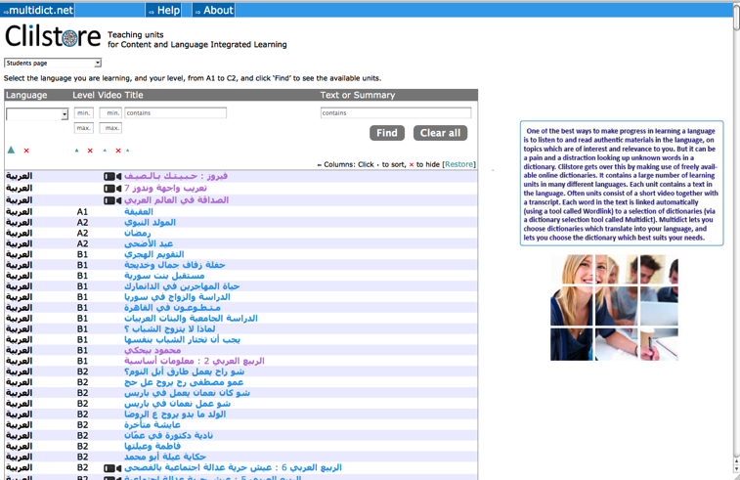

- Buttons on the top of screen are redundant
- Level buttons; all selection buttons should work in the same way
- The buttons with min/max number will only be visible in the advanced option interface
- Tell the user in some way that she/he can click on the line to enter a unit
- Programmer focus on functionality, designer focus on the proper aesthetic design.
- For Arabic, an option to have Arabic appear in Latin letters as well as Arabic
- Widescreen mode option turns up twice, dropdown menu and on the screen, also called two different things. Advanced/wide, which word is best for the purpose it serves.
- Widescreen mode for students
- Font size to change when selecting Arabic language, size 14/16
- Curation system; how can this be applied?
- Change font for Arabic

Presentation of course book
- Caoimhín (Ulster), Rasa, Ana G.S.
- Worked on a template, fixed headings and subheadings etc
- Everything can be changed, first draft
- Folder in dropbox, called Course Book with the latest version of course book, please don’t modify without consulting the team members
- Collecting examples of best practice
- Template for best practice examples, for team members to fill out and send examples to the team
- Distribution of chapters: introduction, case studies, lesson plan, conclusions, acknowledgements, further reading, glossary; suggestions to additional info to be sent to the team
- Case studies; remove primary education, change secondary education to adult education
- Explain copyleft, disclaimer
- Suggestions to references and further reading also native information- (translated titles also) send to the team

Distribution of education level
- Evora- 2 higher edu
- SDE- vocational education 2 examples of best practice
- SDU- 2 higher edu
- Marijampole– 2 adult edu
- Ulster- 1 teaching literature + higher edu
No more than 1 page per case study (no screen dumps, no images, link to exercise in CLILSTORE

Distribution of Levels:
Include one case study for each level A1-C2
- SDU: A1 + B1
- Marijampole: B2 + C1
- Evora: A2 + B2
- Ulster: B2 + B1
- Ana G-S: C2
- SDE B1 + B2

Thursday April 11th

Demonstration of work by Caoimhín SMO since yesterday
- We need to have Lone make the new version of the frontpage with the new text from LLL
- 4 options now in the dropdown menu, with more options being added to the dropdown menu, instead of in view on the screen
- The new layout has been adopted, still some changes to be made
- Arabic is now at the top of the language selection dropdown menu
- Need to change author page- widescreen to author page – more options

Course book case study template
- Each team fills out the template in English and adds them to dropbox
- Deadline 26th April

Plans for the Do It Yourself videos and integration with the eBook version of the Course Book. (Kent)
- Kent will send the transcript to the teams for translation
- Translation deadline was 1st July 2013, waiting for the course book, English version should be ready by end June

Quality Management, check on milestones met. Quality control of achievements
- Generally on schedule (DIY videos delayed approx. three weeks, but will be ready by July 1st as in the WP)
- Achievements reached so far are good
- Quality of ebook version good, on its way
- Clilstore working perfectly
- Quantity of units exceeded the goal
- Teams need to check that they all have a total of 20 units created by the teams, and 20 units created by course participants.
- Not sure whether it was specified which languages the team were to present units in.

Compilation of a list of possible national and international dissemination events or methods that will be implemented in the partner countries to ensure a cross country dissemination and impact on target groups (MPRC)
- Compilation of a list of possible events, Rasa will add information in the dropbox folder, members will fill this in
- Mailing list as proof of dissemination
- Rasa will send a reminder

Each team prepares a schedule and a list of milestones to be met by that team until next project meeting (Evora).
- Rasa will send us an email reminder, but milestones need to be sent to Cecilia by end next week. Preferably ASAP

Summary of the Project plan, responsibilities, and agreed meeting schedule.
- Our next meeting will be just after the Eurocall conference in Evora (as indicated in the meeting evaluations from 2012), i.e. we start at 14.00 on Saturday, September 14th . We stick to the original work plan dates for the Belfast meeting.
- Suggested hotel for Evora, M’ar De AR Muralhas
- Meeting evaluation: http://www.languages.dk/archive/tools/evaluation/MeetingEval/3rd%20meeting%20in%20Valencia.pdf
- Eurocall start 11th September 2013, 3 meeting days 14 after lunch, 15 and 16th travelling home Tuesday 17th
- Full participation in EuroCALL “optional” but advisable.
- TOOLS workshops Thursday afternoon
- Parallel sessions Wednesday
- Conference will close Saturday at 13.00
- Budget for 5 overnight days was set according to Swedish rules… 230 Euro pr day. This means there might be room for one extra day. 5/6 staff days.
- For flight tickets to Evora, there are often good prices to Algarve (Faro) and take a bus to Evora. Lisbon is closest to Evora. Take bus to Evora.

Friday April 12th
The teams travelled back home full of ideas and motivation

TO DO LIST:
- All teams must fill out the best practice case study template for the CLILSTORE WORK BOOK; high priority! Deadline Friday 26th April upload to the coursebook folder in dropbox folder in the case study folder.
- Cecilia- send a copy of the CLIL lesson plan template to Ana G.S and Caoimhín (Ulster)
- Add official high resolution institution logo in a folder called logo in dropbox
- Main CLILSTORE must be finished; the manuals/DIY manuals must be ready by this summer. (1st July) Demonstration at worldCALL, and EuroCALL in Evora.
- All teams must submit 2 articles minimum.
- Distinguish between dialects, think about a way of marking a specific dictionaries and being able to refine your search.
- Kent; move the links to social media to a more obvious/visible place, icons please!

Schedule and milestones until mid-September  Task | Deadline | Partner
Article in www.mprc.lt about Tools meeting in Valencia | 20/apr | MPRC
Prepare case studies for the CLIL book | 26/apr | All
A presentation at APPI (Associação Portuguesa de Professores de Inglês) | 27/apr | Evora
Article for the newsletter | 15/jun | All
Record DIY video | 15/jun | SDE
Edit newsletter | 20/jun | SDE
Write and edit CLIL book | 01/jul | UPV and Ulster
Peer review CLIL book | 01/jul | MPRC
Voice over and edit of English DIY speak | 01/jul | SMO
Second pilot course – Spring 2013 | 01/jul | Evora
Development of course module and pilot course description | 01/jul | MPRC
Software development for CLILSTORE | 01/jul | SMO
Finalizing course module (description of how to offer/ run the courses) | 01/jul | MPRC
Decide which terms to include in the Glossary that will be part of the e-book | 01/jul | UPV
Look into software available to publish e-books | 01/jul | UPV
Prepare screen dumps from Clilstore/Multidict/Worlink to include in e-book | 01/jul | UPV
Advise on Clilstore functionality and design | 01/jul | UPV
3rd biannual report text and financial part | 07/jul | All
Translate CLIL book into Lihuanian | 15/jul | MPRC
Translate DIY speek and record voice over in Lithuanian | 15/jul
Translate CLIL book into Danish | 15/jul | SDE
Translate CLIL book into Portuguese | 15/jul | Evora
Translate CLIL book into Spanish | 15/jul | UPV
Translate CLIL book into Irish (optional) | 15/jul | Ulster
Translate DIY speak and record voice over in Danish | 15/jul | SDE
Translate DIY speek and record voice over in Portuguese | 15/jul | Evora
Translate DIY speek and record voice over in Spanish | 15/jul | UPV
Translate DIY speek and record voice over in Irish (optional) | 15/jul | Ulster
Translate course module/description into Danish | 15/jul | SDE
Translate course module/description into Lithuanian | 15/jul | MPRC
Translate course module/description into Spanish | 15/jul | UPV
Translate course module/description into Portuguese | 15/jul | Evora
Translate course module/description into Irish (optional) | 15/jul | Ulster
Prepare and present poster and educational showcase at Worldcall in July | 15/jul | Ulster
Find books and articles in Spanish about CLIL to include in the Spanish version of the e-book | 15/jul | UPV
Help disseminate the project and its tools at the WorldCALL conference in July 2013 | 15/jul | UPV
Convert CLIL book to eBook format with videos | 01/sep | SDE
Language versions of DIY videos | 01/sep | SDE
Register info about Tools in EfVET conference roundtables info | 01/sep | MPRC
Invite friends to join our social network on facebook, linkedin and twitter | 01/sep | All
Exploitation event mini course South DK VET schools | 01/sep | SDE
Exploitation course in Malta (August two weeks) if possible | 01/sep | Ulster
Exploitation course in Malta (August two weeks) | 01/sep | SDE
Test drive Gaelic units with Ceòlas | 01/sep | SMO
Test drive Gaelic units with Summer short courses | 01/sep | SMO
Test drive Gaelic units with Distance learners | 01/sep | SMO
Help prepare the Clilstore workshop for the EUROCALL 2013 Conference in Évora | 01/sep | All
Framework for making interviews during the Eurocall conference | 01/sep | All
Disseminate project in Facebook, Wordpress and Linkedin | 10/sep | MPRC
Add entries and comments in Facebook, Wordpress and Linkedin | 10/sep | All
Enter tweets | 10/sep | MPRC
Provide information to the CEL members (Research Centre) about TOOLS project | 10/sep | Evora
Submit article about TOOLS/CLIL for professional magazine | 10/sep | All
Clilstore units in Lithuanian | 10/sep | MPRC
Clilstore units in Arabic | 10/sep | SDU
Clilstore units in Danish | 10/sep | SDE
Clilstore units in Spanish | 10/sep | UPV
Clilstore units in Irish | 10/sep | Ulster
Clilstore units in Scottish Gaelic | 10/sep | SMO
Clilstore units in Portuguese | 10/sep | Evora
Build upon contacts in target sectors | 10/sep | Ulster
Interview twenty eurocall participants about Clilstore functions and suitability | 15/sep | All

